Computer Organization and Architecture (EET2211)

**LAB III: Analyze and Evaluate the Array Operations using 8086 microprocessors.**

**Siksha ‘O’ Anusandhan (Deemed to be University), Bhubaneswar**

|  |  |  |  |
| --- | --- | --- | --- |
| **Branch: Section:** | | | |
| **S. No.** | **Name** | **Registration No.** | **Signature** |
|  |  |  |  |

# Marks: /10

**Remarks:**

# Teacher’s Signature

## OBJECTIVE:

* 1. Find the largest/smallest number (8-bit number) from a given array of size N.
  2. Arrange the elements (8-bit number) of a given array of size N in ascending/descending order.

## PRE-LAB

For each objective in prelab describe the following points:

* Write the assembly code with a description (ex. Mov ax,3000h – ax<-3000h)
* Examine and analyze the input/output of assembly code.

## LAB

Note: For each objective do the following job and assessment:

* Screenshots of the Assembly language program (ALP)
* Observations (with screenshots)

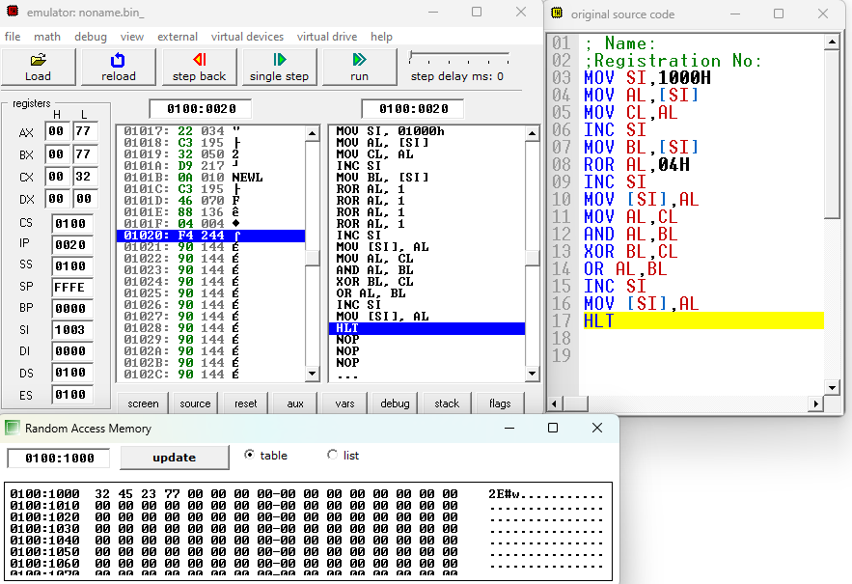

**Fig. 1.** Execution result of addition using immediate and direct addressing mode of 8086 emulator.

From this result, I have observed……

**Input: Output:**

|  |  |  |
| --- | --- | --- |
| **Sl.**  **No.** | **Memory Location** | **Operand (Data)** |
| **1** |  |  |
| **2** |  |  |
| **…** |  |  |

|  |  |  |
| --- | --- | --- |
| **Sl.**  **No.** | **Memory Location** | **Operand (Data)** |
| **1** |  |  |
| **2** |  |  |
| **…** |  |  |

## CONCLUSION

1. **POST LAB**
2. What are the directives available for data declaration in 8086 microprocessors?
3. State the difference between END, ENDP, and ENDS directives.
4. Find the sum and average of a given array of size N.